**2. Hello World RESTful Web Service:**

**//HelloController.java**

package com.cognizant.spring_learn.controller;

import org.slf4j.Logger;

import org.slf4j.LoggerFactory;

import org.springframework.web.bind.annotation.GetMapping;

import org.springframework.web.bind.annotation.RestController;

@RestController

public class HelloController {

private static final Logger LOGGER = LoggerFactory.getLogger(HelloController.class);

@GetMapping("/hello")

public String sayHello() {

LOGGER.info("START");

LOGGER.info("END");

return "Hello World!!";

}

}

**//SpringLearnApplication.java**

package com.cognizant.spring_learn;

import org.slf4j.LoggerFactory;

import org.springframework.boot.SpringApplication;

import org.springframework.boot.autoconfigure.SpringBootApplication;

import org.slf4j.Logger;

import org.springframework.context.ApplicationContext;

import org.springframework.context.support.ClassPathXmlApplicationContext;

@SpringBootApplication

public class SpringLearnApplication {

private static final Logger LOGGER = LoggerFactory.getLogger(SpringLearnApplication.class);

public static void main(String[] args) {

LOGGER.info("START");

displayCountry();

SpringApplication.run(SpringLearnApplication.class, args);

LOGGER.info("END");

}

public static void displayCountry() {

ApplicationContext context = new ClassPathXmlApplicationContext("country.xml");

Country country = (Country) context.getBean("country", Country.class);

LOGGER.info("Country : {}", country.toString());

}

}

**//Output:**

**Console:**

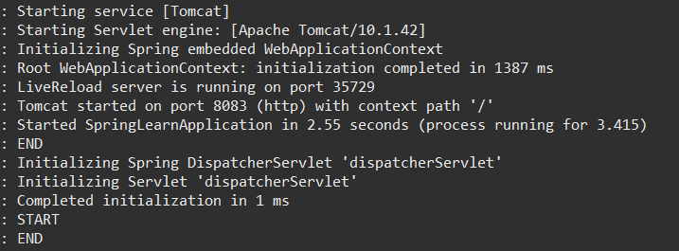

[**http://localhost:8083/hello**](http://localhost:8083/hello) **in the browser.**

